**Project Report**

**CS 157A**

**Project 1: eTRT System**

**By**

**Endalkachew Aychiluhim**

**…….**

**…….**

**November, 2019**

|  |
| --- |
| Copyright © 2019 |
| Endalkachew Aychiluhim,..... ……... |
| ALL RIGHTS RESERVED |

**ABSTRACT**

**eTRT Java Application**

By Endalkachew Aychiluhim, …………….., ………………………

eTRT is a java application that patient data/information storage platform. This application developed by using both mysql and java programming. We mainly use mysql workbench and Mysql server and eclipse to develop this application. It has

**Table of Contents**

[**1.**](https://docs.google.com/document/d/1Kc3ETwqM9IIbL66DaQDidXAWs4I8ZrAOqF2JaPbD0yw/edit#heading=h.a68x3vnmu4v5) **Problem Statement 4**

**2**[**. Project Requirements**](https://docs.google.com/document/d/1Kc3ETwqM9IIbL66DaQDidXAWs4I8ZrAOqF2JaPbD0yw/edit#heading=h.5hblvknoatoo)

**3. Architecture Design**

**4. Chosen Technology/ Tools Used**

**5.** [**System Implementation**](https://docs.google.com/document/d/1Kc3ETwqM9IIbL66DaQDidXAWs4I8ZrAOqF2JaPbD0yw/edit#heading=h.267b5boiak5u)

**6. System Implementation/ Description of the implementation**

**7.Instructions to deploy and run your application**

**8.Contributions of each team member**

**9.**[**Con**](https://docs.google.com/document/d/1Kc3ETwqM9IIbL66DaQDidXAWs4I8ZrAOqF2JaPbD0yw/edit#heading=h.lcwfl21ygl9)**clusion and Future Work**

## **Problem Statement**

The primary goal of this project is to create a platform for eTRT to store patients and visitors information which helps to register and manage patients information for healthcare companies. Just as any healthcare or hospital patient registration form, this application provides a platform that simply accessed by healthcare providers, nurses, customer services people, actual patients and visitors. With this convenience we will need to utilize different technologies to be able to create this. Therefore another goal is to use a MySQL server and MySQL Workbench to store a reliable and accurate information of patients and visitors. Our application is essential in allowing the patients to be able to easily conduct to register and access their information in the database.

Yet another goal that we have with this project is to create a usable and reliable service that we can call our own. This project will be one of our priorities for this semester and we want to make it the best that we possibly can. Storing and having a usable and reliable data will help to provide accurate and secure data of patients.

In order to make our project we will need to learn some new technologies that most of us haven’t been exposed to yet and we will need to stay on top of our plans and the requirements to have it done before the due date. In order to do this we will need to continue to study and practice with MySQL database and server for advance knowledge.

**Project Requirement**

eTRT will follow typical functional and nonfunctional requirements. We will ensure that it encompasses non-functional requirements such as, as an example this project need u[sabilit](https://docs.google.com/document/d/13wV1LdbVDIWxMq_8zAkXYeyGQIsQFCcuxEs-00ySyk0/edit#heading=h.7sfw2yz94ion)y, r[eliability](https://docs.google.com/document/d/13wV1LdbVDIWxMq_8zAkXYeyGQIsQFCcuxEs-00ySyk0/edit#heading=h.muaxyk4qch97), p[erformance](https://docs.google.com/document/d/13wV1LdbVDIWxMq_8zAkXYeyGQIsQFCcuxEs-00ySyk0/edit#heading=h.74y5mr1qsxgm), [supportability](https://docs.google.com/document/d/13wV1LdbVDIWxMq_8zAkXYeyGQIsQFCcuxEs-00ySyk0/edit#heading=h.xqokjk6ps3im) [implementation](https://docs.google.com/document/d/13wV1LdbVDIWxMq_8zAkXYeyGQIsQFCcuxEs-00ySyk0/edit#heading=h.py5z0phyp51u), [interface](https://docs.google.com/document/d/13wV1LdbVDIWxMq_8zAkXYeyGQIsQFCcuxEs-00ySyk0/edit#heading=h.7cc13f1opy60), and [operation](https://docs.google.com/document/d/13wV1LdbVDIWxMq_8zAkXYeyGQIsQFCcuxEs-00ySyk0/edit#heading=h.vjrhnmmm7elt)(access). In general, these non-functional requirements explain the overall functionality of the system. The functional requirements include the actual interface display that users can access to use the eTRT application.

**Architecture Design**

* **Sequence diagram for patient**

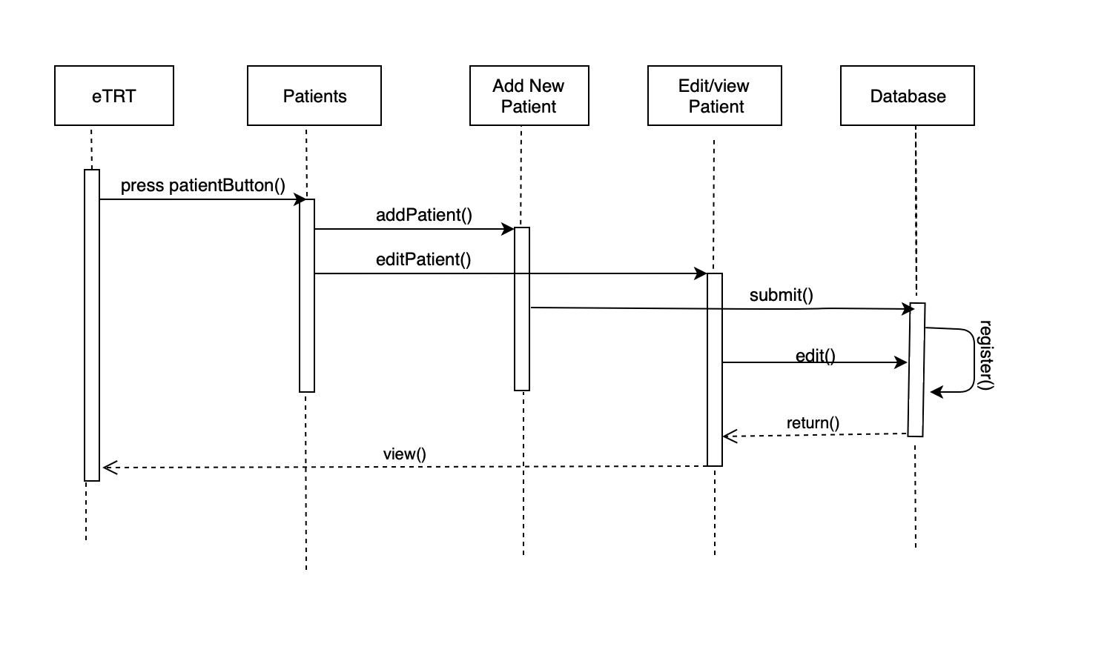

* **Sequence diagram for Visit**

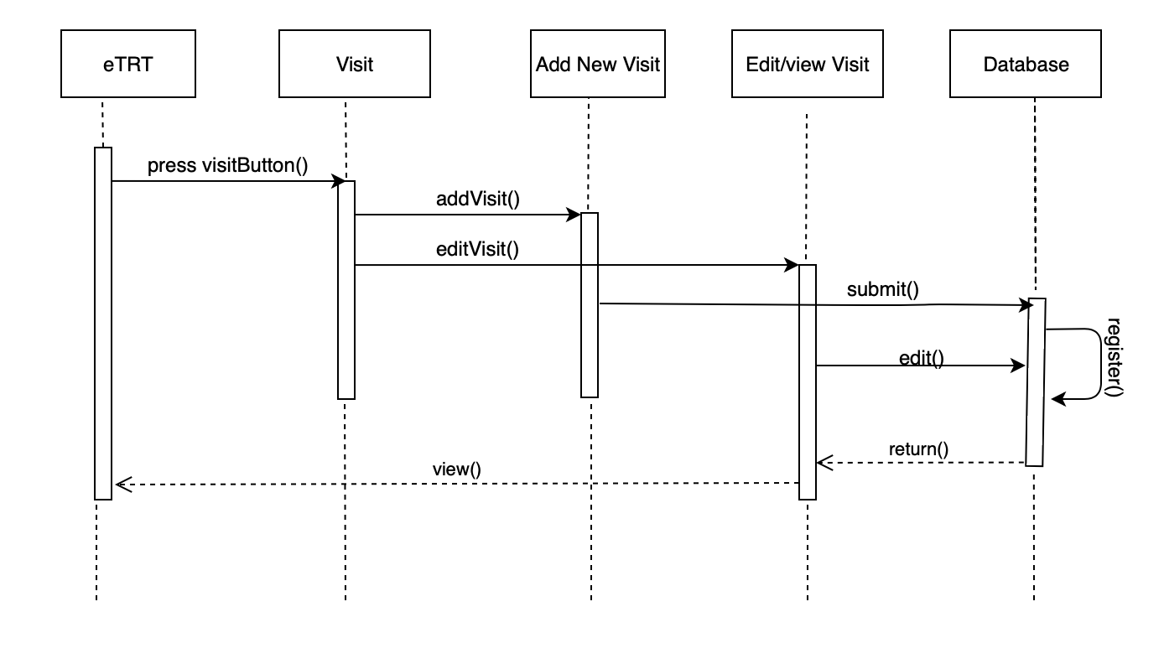

**Chosen Technology/ Tools Used**

When creating any piece of software one of the most important decisions to make are which tools we will use for the project. Some tools are very powerful and dramatically reduce the amount of time needed to work on certain things and, just like in any other field, choosing the right tools for the job is very important. We needed to gauge the different tools we would use beforehand and it was something that we would continuously change as the project progressed. The following tools are the main ones that we used, although it is not an exhaustive list as many smaller tools were used but it would be unreasonable to list every single one on here.

* Eclipse
  + We decided to use Eclipse for the front-end work as it would make our work a lot easier as it has many libraries that we coding. Not only does it make things easier, it also supports the amount of depth that we want to have in our project. It also supports a language that all three of us know in Java. This is where the majority of our work was completed and tested.
* Github
  + Version control and management is a very important tool in the programming field. Github provides that version control for our group as we can all work on different things and still maintain our code within a manageable state. It provides ease of use in sharing and updating our project throughout its lifecycle. It also connects easily with all of the other tools that we are using, especially eclipse.
* MySQL Server and Workbench
  + Our data needs to be stored somewhere, and like before, we narrowed it down to two choices, hosting and maintaining our own servers or using a system that was already established. We chose to use MySQL server and MySQL Workbench for its ease of use and system that easily integrates with our project on eclipse.

**System Implementation/ Description of the implementation**

**Instructions to deploy and run your application**

**Contributions of each team member**

Endalkachew Aychiluhim:

Keon:

Mustafa: